The Atmosphere-Space Interactions Monitor (ASIM)
on the International Space Station

Torsten Neubert¹, Victor Reglero², Nikolai Østgaard³

- National Space Institute, Technical University of Denmark (DTU Space), Kongens Lyngby, Denmark, neubert@space.dtu.dk
- Image Processing Laboratory, University of Valencia, Valencia, Spain
3. Birkeland Centre for Space Science, University of Bergen, Bergen, Norway

The Atmosphere-Space Interactions Monitor (ASIM) is an instrument suite for the International Space Station for measurements of lightning, Transient Luminous Emissions (TLEs) and Terrestrial Gamma-ray Flashes (TGFs). Developed by the European Space Agency (ESA), it will be launched in the spring of 2018 to be mounted on an external platform on ESA’s Columbus module. The instruments include an X- and Gamma-ray monitor with direction-finding capabilities of TGFs (coded mask) measuring photons from ~20 keV to 20 MeV, and an array of three photometers and two cameras measuring in the bands: 240-300 nm, 337 nm and 777 nm. The presentation will give an overview of the ASIM mission and its instruments.

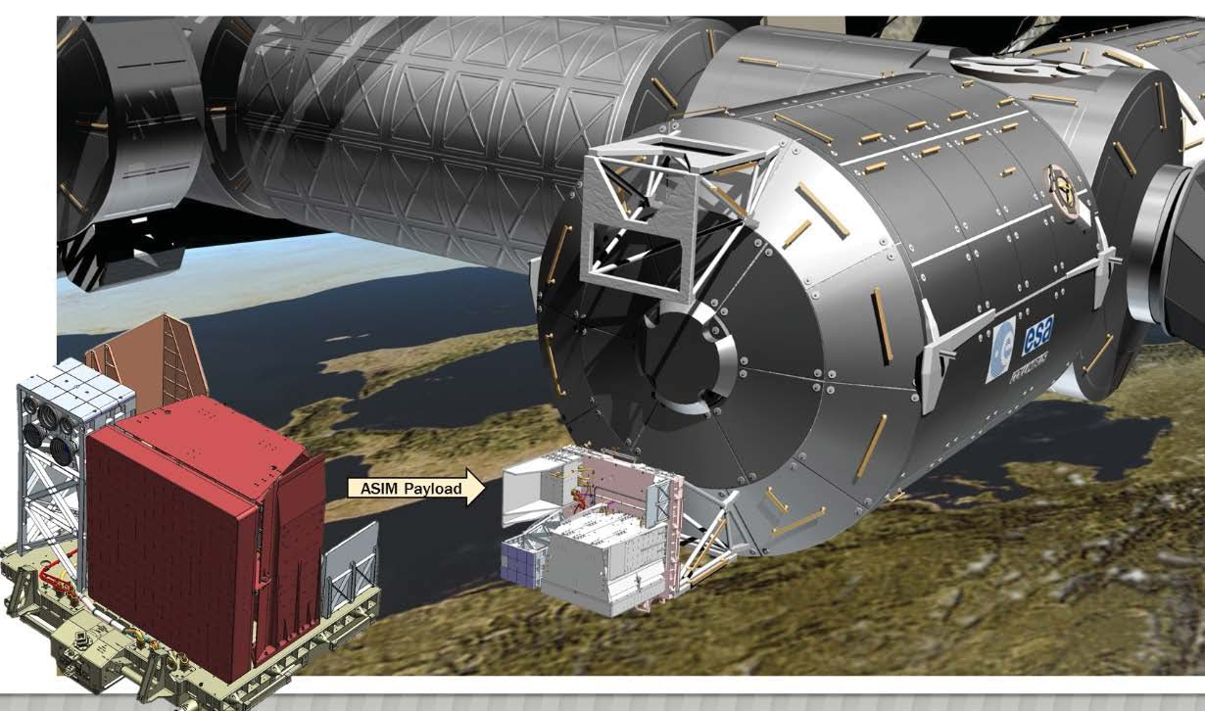

Problem: Find the dates and times during April, 2018 that ASIM can take night-time observations coincident with ground observations from Panama. Use http://www.heavens-above.com/ and require that the ISS elevation >60 deg. You will need to create an account and to change the location to Panama. Then use the 10-day predictor.

Submit your abstract for the 1st SAINT Summer School to conf.atmos@event.upc.edu before June 15, 2018. We are looking forward to see you in Barcelona!

